Home Energy Management System

Group 13: Ryan Jones, Zineb Heater, Dennys kilgore

School of Electrical Engineering and Computer Science, University of Central Florida, Orlando, Florida, 32816-2450

Abstract --- Two different devices are used; one central unit including a microcontroller, a wireless chip, a current sensor, a voltage sensor and a power relay and one unit including one LCD display and a wireless chip. The communication between all devices will be done through XBee communications. Each board will have a voltage divider as a voltage sensing circuit; a current sensor, an XBee chip, a power relay and an optical isolator. The user will have the ability to track and control power usage via the LCD touch screen.

I. Introduction
Throughout the centuries, energy as a concept has worked its way into nearly every scientific application, through gadgets and gizmos and into the homes of everyday Americans. According to the U.S. Department of Energy, the United States currently consumes the most of the world’s energy, and 21% of the country’s energy consumption comes from residential use. In an effort to curb these facts in the future, many have thought to turn towards renewable energy sources. However, before new energy sources are created, the idea of responsible energy consumption should first be considered. In fact, in order to properly integrate renewable energy sources, people will need to be aware of their excessive energy usage on a daily basis in order to curb their dependency on non-necessities, such as keeping lights on when out of the room or plugging in appliances no longer in use.
In studies conducted in 2000, Vampire Draw (referencing the power used by electronic devices when they are supposed to be dead) accounted for upwards of 13% of the average American household energy bill. This means that 13% of the household energy bill is from wasted power – electronics that are not in use and are not benefiting the homeowner, except they may merely save a few moments when the device initially starts up. Much of the excess energy in these devices is dissipated as heat, which also raises home cooling costs showing as a double expenditure on the bill.
While renewable energy is a very altruistic motive as far as the environment and futuristic goals are concerned, there is also a very pertinent and personal motive to energy management – to save money by reducing household energy usage, thus reducing the final total on the monthly bill. As the world moves forward, technological advances will only add to the growing list of gadgets found in American homes. Not only are there cell phones, game consoles, cable boxes, desktop computers, laptops, and eBook readers, there are the chargers, controllers, and monitors associated with each that are left plugged in throughout the day.
The Home Energy Management System is a project that handles the opposite end of the power spectrum as renewable energy, sustainability. Sustainability is as important as finding sources of renewable energy. At the current pace of the country, we may have sufficient energy reserves and resources to last decades, but why can we not stretch that even further? The world needs to act today in preparation for the future, and it begins with sustainability projects.
The Home Energy Management System empowers the user to save hundreds of dollars on electric bills. Electricity bills are rising and there is no end to it unless if we make the right actions and implement new methods to save energy and money. With the Home Energy Management System, the user can cut down on costs and find out what appliances are actually worth keeping plugged in and those that are consuming way too much energy. The U.S Department of Energy reports that 20% of the country’s electric bills come from items that are left plugged in when they are not in use, or items that are in standby mode. With the Home Energy Management System, the user can monitor the energy eaters in their homes, cut down their electric bills and protect the environment by using fewer resources at the same time.
The goal of this project is to give users an idea of how much energy is being used throughout the month and where their major energy drains are within their home. The project aims to be a sustainability project. As well, the project will provide the users with the ability to control the power going into different areas of their homes. The idea is to combine a power switch and power meter into one unit, and allow users to view the data and control the switch wirelessly.
The product will be designed so that one central unit can be used to record the data and function as a server for the controlling application. Due to differing layouts of houses, it would be difficult to predict whether a central unit will always be able to connect to all of the switch/meter units, so a wireless protocol that uses mesh networking is ideal. That way, regardless of the size or structure of the house, all data can be communicated back to the central unit without issue. The XBee protocol will be used as it combines low operating power consumption and the necessary wireless networking.
The measuring accuracy is expected to be within 10% as this will be sufficient in providing the user with a fairly accurate predictor of their monthly power bill, especially considering current methods (i.e. guessing) could yield up to 50% inaccuracy.

The data will be formatted in a user-friendly way to increase desire of use and remove any anxiety those not too computer literate might foster. As well, the application will easily display all pertinent information attained from the device. While the control of the house’s energy consumption from anywhere in the world is the ultimate goal, the users will also be able to effectively budget their energy expenditures to ensure they meet their monthly household budget.

II. Component Selection
The microcontroller to be used will be an essential part of the whole design. Not only does the microcontroller have to be able to easily interface with the different components of the design, but it also has to have enough output and inputs pins to manage all the data being received and sent. The microcontroller has to receive data from the current sensor, convert it to power and transmit it to the LCD screen. This requires the microcontroller to have a large number of input and outputs pins as there will be different tabs available to the user to program the microcontroller.
XBee modules are used in our design. The XBEE modules are the core of the mesh communications protocol. They provide an easy to use Application Interface and handle all the mesh networking by themselves. These modules offer several advantages such as the ease of use and the possibility of being tested independently from the microcontroller.
A Graphic User Interface (GUI) is used in order to allow the user to navigate the system. Many functions of a GUI require an advanced processor, so an FPGA will not be ideal. In addition, GUIs require some sort of an operating system to be run. The operating system must be chosen carefully. Because a full operating system will not be possible in such a device, the system will need to be run from a lightweight, minimalistic operating system.
As far as the analog parts go, a power relay, a voltage divider circuit and a current sensor are used to measure the power.

A. XBee communications
The wireless transceiver we decided to use was the XBee. XBee is a wireless solution that is produced by Digi, which was based on the Zigbee Protocol. Digi has created a radio that implements all of the best of Zigbee without the mess. For instance, it uses an AT command set which makes the XBee much easier to implement directly out of the box. The latest version supports mesh networking, though this requires much more effort and implementation for the user. However, unlike Zigbee, the XBee allows the group members to take full advantage of their knowledge to create a reliable mesh network without going beyond the capabilities expected.

As well, the range for the XBee unit is perfect – 100 meters is described as the short range, which allows for attenuation through the walls of a house yet would still cover almost any normal residence’s width or length. If not, the mesh networking would make up for any loss of signal. Compared to the Nordic radio, the XBee unit is much more expensive and uses more power, but it achieves higher accurate data rates ensuring the user’s information get from point A to point B. While the Nordic radio has a strong battery life, it is assumed the project’s final device will be connected to an AC power line at all points, which makes the expected battery life of the XBee null and void.

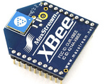
Figure 1- XBee chip from Spark fun Electronics

B. Power relay
A power relay is and electrically operated switch. It is designed to withstand the current of the electrical circuit into which it’s inserted and to cut off the electrical circuit under load. Many relays use an electromagnet to operate the switching mechanism. A power relay is going to be used in our application as we need a device that can cut the power of an appliance. The relay uses an electromagnet to open and close an electrical circuit. The basic design of a relay consists of an electromagnet coil, an armature, a spring and some contacts. When it comes to the power relay, we decided to use a solid state relay over an electromechanical relay. The reasons behind our choice are the fact that the solid state relay is smaller that electromechanical relays. This will save us space in the PCB. Another reason is that the solid state does not have any moving parts, which offers improved reliability. The other reason is the fact that a solid state relay does not have contacts, so we do not have to worry about wear issues. The relay will basically last forever as long as it’s used per the manufacturer requirements. The cost was also considered. We decided to use the CX240D5 solid state relay. It has ratings of 5A, has AC or DC control and Zero-crossing (resistive loads) or random-fire (inductive loads) output.
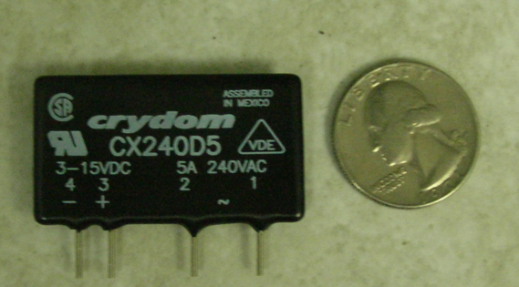
Figure 2- Solid state relay

C. LCD Screen
Displayed below in figure 3, is an image of a 4 x 20 character LCD that is of the same type that will be used in the project design. The image below shows a small variety of the types of symbols that can be displayed by using this type of an LCD screen, and gives the reader a rough idea as to what a potential output could look like.

D. Microcontroller
The Arduino family of microprocessor boards has everything one could possibly want in one convenient package. The Arduino family offers several analog inputs, twice as many digital outputs, and interoperability with various products. One concern in using the Arduino family is the availability of a C programming language. Conversely, the Arduino family has a development environment for Windows, which uses a modified version of the C programming language, with additional specific commands for controlling the pin functions of the digital pins and the special multi-use pins.
Figure 3- Arduino Microcontroller

E. current sensor
A Hall Effect current sensor was used to sense the current. We chose this kind of sensors over the other technologies because of safety and reliability considerations. As discussed earlier, the Hall Effect current sensor will be totally isolated from the high voltage electrical system which eliminates many safety concerns. Also, the Hall Effect current sensor will not get hot while we are measuring the current. The cost was also one of the considerations; the Hall Effect current sensor did not cost us more than $20 per unit. We chose the AMP25 Hall Effect Linear sensor. It has a linearity of 1%, accuracy of +/-2%, 25 Amps rating, an operating temperature of -55ºC to +125ºC, it requires a voltage supply Vs from 4.5VDC to 10VDC, has an offset voltage of Vs/2 +/-2% and the output voltage is proportional to Vs.

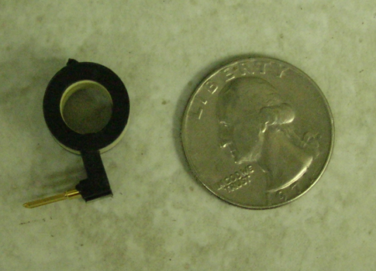
Figure 4- Current Sensor

III. Schematic
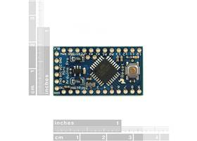
A. XBee Radio Chips
As stated above, our means of communications for this project was through using XBee radio chips. The pin configuration can be seen below in the following figure.
Figure 4: Pin Layout for the XBee
Figure 5 illustrates the schematic of the XBee adapter. This allows the XBee to be easily programmed using a cord that connects to the important six pins stated above and any computer.
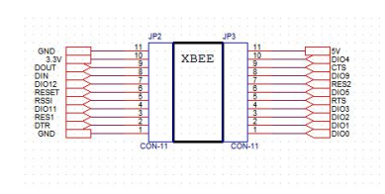
Figure 5: schematic of the XBee

B. Relay/Power Sensor
The figures below in figure 6, 7 and 8 represent the schematic of the power relay, voltage sensing circuit and the current sensor.
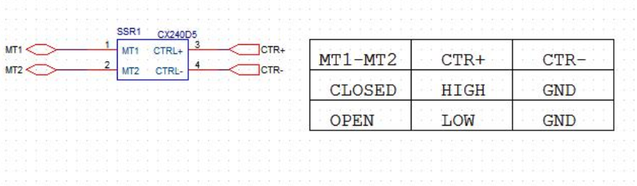
Figure 6: Power relay schematic
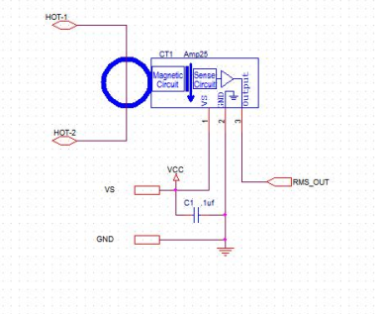
Figure 7: Current sensor schematic
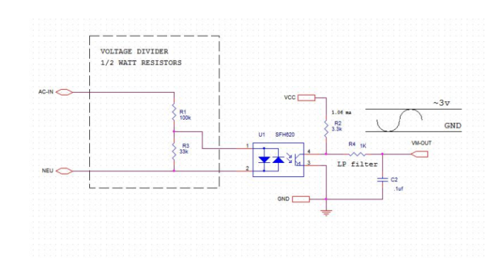
Figure 8: voltage sensing unit schematic

C .Complete system schematic
The following figure represents the complete system schematic.
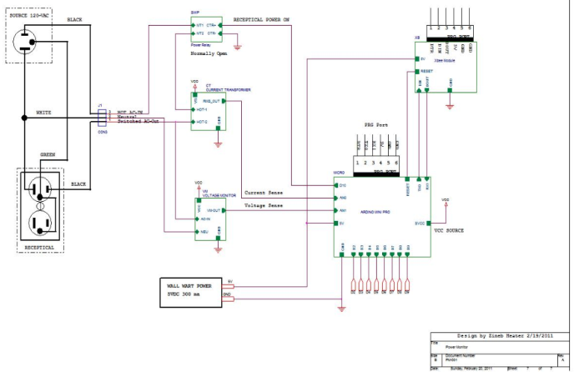
Figure 9: System schematic

The system as a whole takes as an input the hot line of the AC power outlet and produces as an output a hot line of AC power, it also takes in the neutral line but passes that directly out. The ground for the outlet is passed directly from the input outlet directly to the output outlet with no interaction within the system.

V. Block Diagram
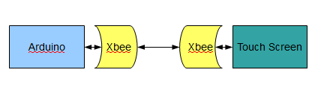
Figure 9: Hardware Block Diagram
The whole hardware block diagram is seen in Figure 9. The touchscreen unit will send commands to the Switch units via the Xbee units. This is the main mode of communication for the project.

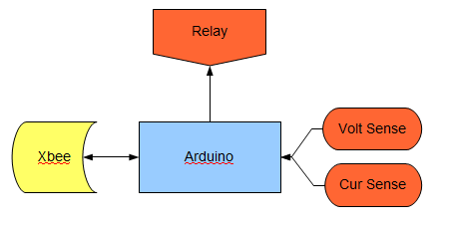
Figure 10: Switch Unit Block Diagram
The Switch unit block diagram can be seen in Figure 10. The Arduino will communicate with the XBee unit, receiving commands and transmitting the measurements to the touch screen. The arduino commands the Relay as an output only, supplying the on/off signal. It also has the voltage sensor and the current sensor as only inputs, which it reads the voltage supplied by these parts.

Figure V.11: Embedded System Block Diagram
The embedded system should work together to give a seamless user experience. The block diagram in figure 11 shows how this will be done. The touch screen should accurately find clicks that correspond to the screen output, and send a click message to the Mouse Click Listener. The Mouse Click Listener will then notify the operating system that an object was clicked, and send that message to the C++ assistant for processing.
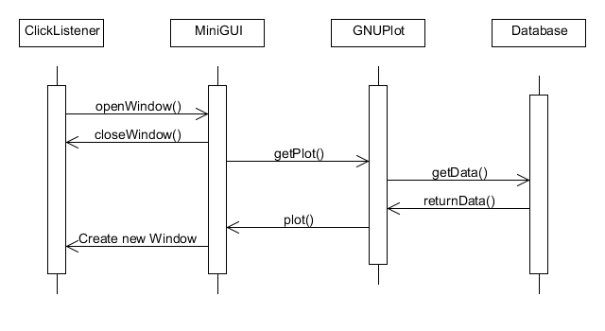
Figure 12
Each screen should close the previous screen, and open only the new, previously selected screen. At no time should more than one screen exist at a time. Thus, the MiniGUI must close each window every time the user wishes to navigate to a new screen. The C++ assistant will tell the MiniGUI to update to whatever screen or action that was clicked by the user. GNUPlot will become active whenever a window containing one or more graphs becomes what is output on the screen. This can be seen in the Sequence Diagram in figure 12.

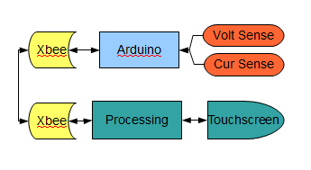
Figure 13: Data Flow
Figure 13 shows the data flow for the entire project. The sensors convert the current and voltage to an analog voltage which is converted to a digital value by the Arduino. This is sent to the XBee which sends the data to the touch screen XBee this XBee sends the data to be processed and stored. The touch screen can then access this data to draw graphs and can give user inputs to the processoring unit.
VI. Final Product
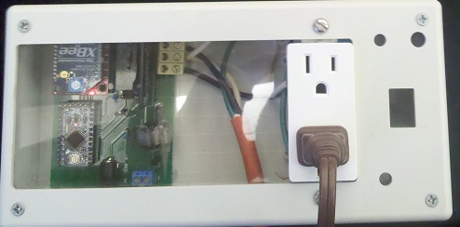
Figure 14: Sensing/Switching Unit
The final sensing unit is as seen in Figure 14. There is a box that houses the sensing PCB, seen in figure 15, as well as the wiring and power outlet. The sensing PCB houses all the sensing circuit parts and accepts the incoming hot and neutral lines while the incoming ground is passed directly to the ground of the outlet. The microcontroller starts up without any user interaction and starts transmitting data right away. This is received by the touch screen unit and processed for display on the screen. The screen is housed in its own box that can be mounted anywhere in the house.
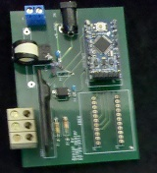
Figure 15: Sensing PCB
Figure 15 shows the printed circuit board designed by team member Zineb Heater. It holds all the sensing and switching electronics that make the end unit work.
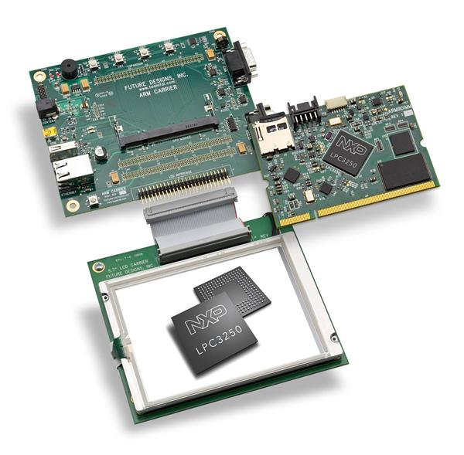
Figure 16: Touch Screen unit
The touch screen being used is seen in figure 16. It connects to the XBee unit using RS232 and has an ARM processor to handle all of our processing needs. It will operate the software designed by Dennis Kilgore, of which the main screen can be seen in figure 17.
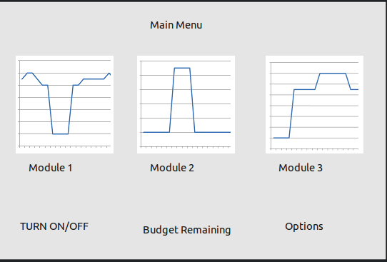
Figure 17: Main Screen of User Interface
VII. Conclusion
With rising energy costs people are becoming more aware of their energy usage, and reducing it. With population growing at exponential rates, the supply of electricity may begin to outstrip the demand and people will be forced to look at their energy usage in a limited light. Hopefully the future of this technology is included in every electronic and people will be able to accurately monitor and track their energy usage to better adapt to the rising demand for electricity.

Sources
[1] “Arduino” 27 October 2010
<http://arduino.cc/>
[2] “XBee Product Manual” 5 November 2010
<http://ftp1.digi.com/support/documentation/90000991_C.pdf>
[3] “Pulling the plug on standby power”22 October 2010 <http://www.economist.com/node/5571582?story_id=5571582>

Ryan Jones is a Senior Electrical Engineering student at the University of Central Florida. He is currently unsure of his future path but would like to pursue a career in the electrical engineering field. Following graduation he will start his job search.

Zineb Heater is a Senior Electrical Engineering student at the University of Central Florida. She has been accepted to graduate school and plans on pursuing her Masters and Ph.D in Electrical Engineering at UCF in RF communication and antenna design. She is also currently interning at the Kennedy Space Center.

Dennis Kilgore is a Senior Computer Engineering student at the University of Central Florida. He is planning on continuing work on this project, and hopefully follow it to a commercial product.

